

Remembrance Wreath Sponsorship Form
Location ID: PAWCVM, Fundraising Group ID: PA0576

Wreath placement at Washington Crossing National Cemetery will be on Saturday, December 14, 2024

Name/Company: ___________________________________________________________________
Address: __________________________________________________________________________
City/State: _________________________________________________________________________
Phone: Email: ___________________________________________

The above-listed information is protected by the Privacy Act of 1974, the Freedom of Information Act and our international policies and practices. This information is never shared with outside agencies.

*All wreaths supplied by WAA for Washington Crossing National Cemetery are paid for by donations from individuals, private and/or company sponsorships*

Wreath Request (donation is $17.00 per wreath.)
Number of wreaths requested: _________ x $17.00 = $ _____________
Monetary donation: $ _________________

*For every 2 wreaths purchased by you, WAA will donate 1 FREE wreath* ________________________________________________________________________________

TO DONATE BY MAIL: Send completed above portion of this form with your check payable to Washington Crossing Wreaths for Veterans to:

Washington Crossing Wreaths for Veterans
PO BOX 731
Langhorne, PA 19047

TO DONATE ONLINE: Go to “wreathsacrossamerica.org/PA0576” OR, Scan the QR code
Click on SPONSOR WREATHS, select the number of wreaths to purchase or contribute click on REVIEW MY SPONSORSHIPS, review and click on START CHECKOUT (Wreath donations must be posted no later than November 24, 2024 to count towards this year’s total).

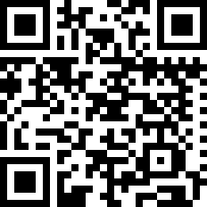

Contact Us
Email: wcwreaths@gmail.com
Web: www.wcwreaths.org
Facebook: Washington Crossing Wreaths for Veterans

